Figure 1:

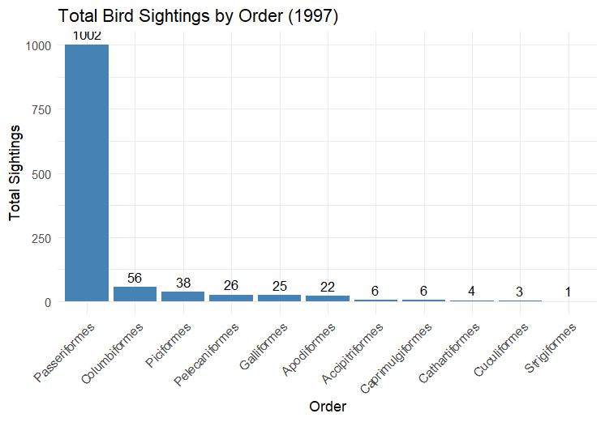

Figure 2:

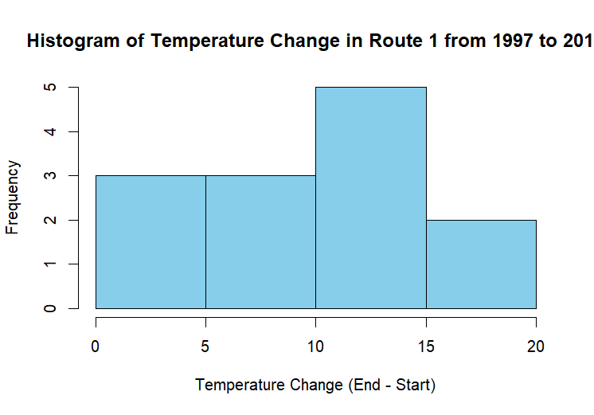

Figure 3: